Steps to Install Visual Studio Code on Windows

Step 1: Visit the Official Website of the Visual Studio Code using any web browser like Google Chrome, Microsoft Edge, etc.

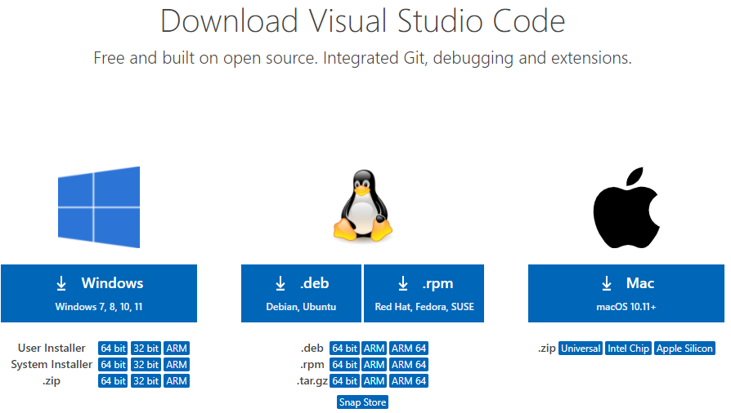

Step 2: Press the “Download for Windows” button on the website to start the download of the Visual Studio Code Application.


Step 3: When the download finishes, then the Visual Studio Code Icon appears in downloads folder.

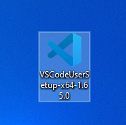

Step 4: Click on the Installer icon to start the installation process of the Visual Studio Code.

Step 5: After the Installer opens, it will ask you to accept the terms and conditions of the Visual Studio Code. Click on I accept the agreement and then click the Next button.

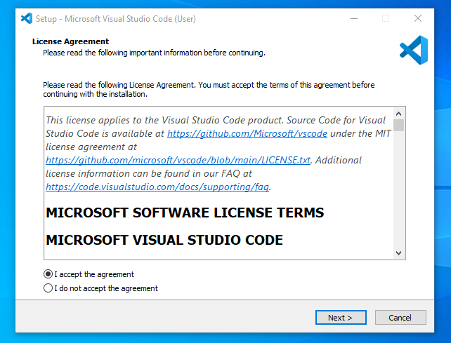
Step 6: Choose the location data for running the Visual Studio Code. It will then ask you to browse the location. Then click on the Next button.

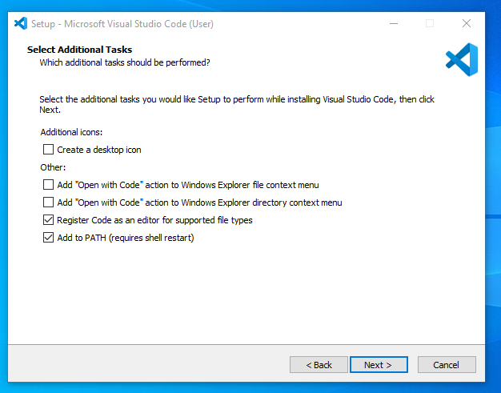

Step 7: Then it will ask to begin the installation setup. Click on the Install button.

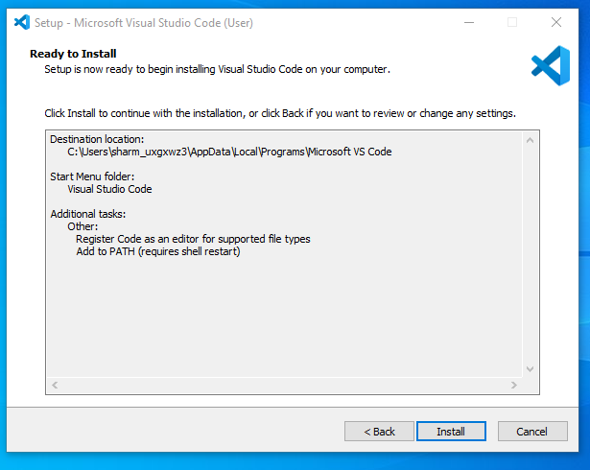

Step 8: After clicking on Install, it will take about 1 minute to install the Visual Studio Code on your device.

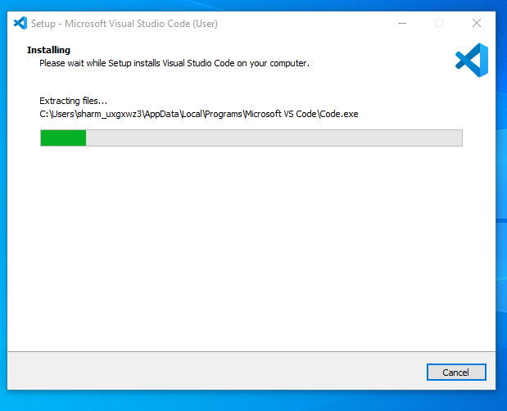

Step 9: After the Installation setup for Visual Studio Code is finished, it will show a window like this below. Tick the “Launch Visual Studio Code” checkbox and then click next.

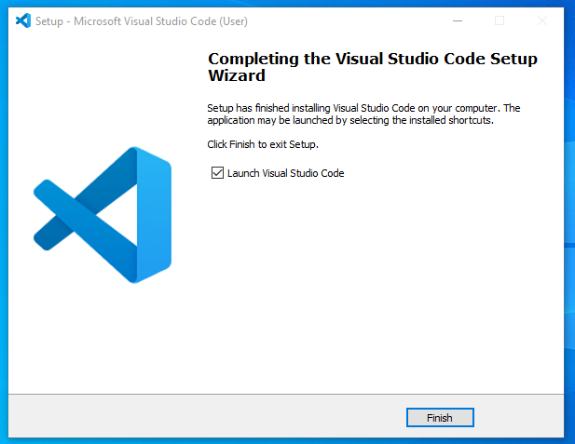

Step 10: After the previous step, the Visual Studio Code window opens successfully. Now you can create a new file in the Visual Studio Code window and choose a language of yours to begin your programming journey!

